**Exercise 1**

Create views like image below:

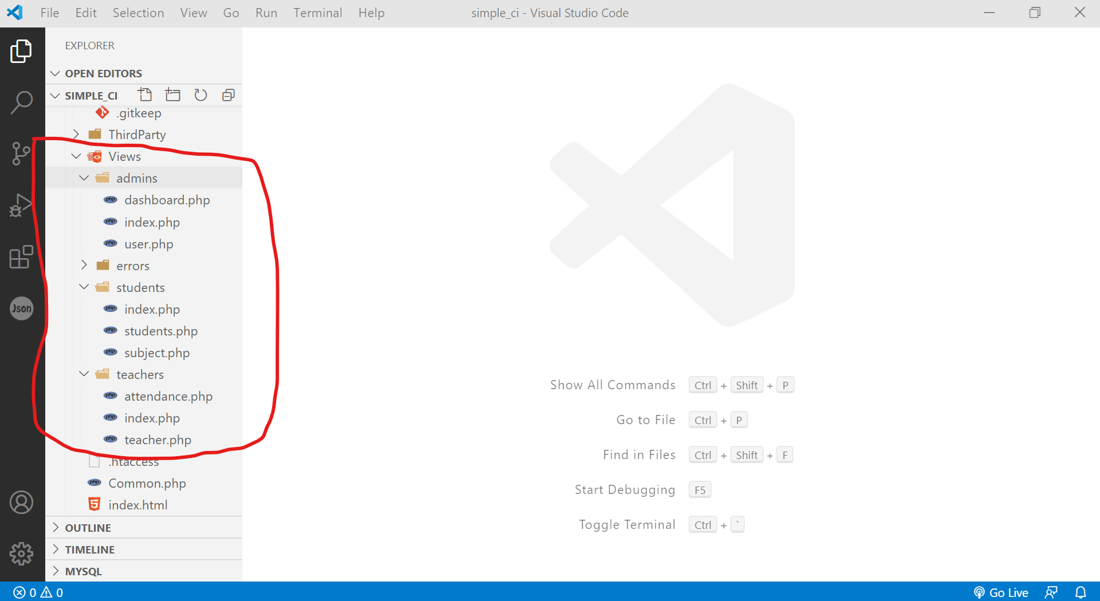

|  |  |
| --- | --- |
| **Admins Views** | |
| File name | Text in side file |
| dashboard.php | <h1> Dashboard views </h1> |
| index.php | <h1> Admin default views </h1> |
| user.php | <h1> User list views </h1> |

|  |  |
| --- | --- |
| **Teachers Views** | |
| File name | Text in side file |
| attendance.php | <h1> Attendance views </h1> |
| index.php | <h1> Teacher default views </h1> |
| teacher.php | <h1> Teacher list views </h1> |

|  |  |
| --- | --- |
| **Students Views** | |
| File name | Text in side file |
| subject.php | <h1> Subject views </h1> |
| index.php | <h1> Student default views </h1> |
| student.php | <h1> Student list views </h1> |

Create controllers:

- **Admin**: return all view in admins folder

- **Student**: return all view in student’s folder

- **Teacher**: return all view in teacher’s folder

**Expected routes**

**Admin controller:**

/admin

-> call the controller Admin, function index () and return view index

/admin/dashboard

-> call the controller Admin, function showDashboard and return the view dashboard

/admin/user

-> call the controller Admin, function viewAllUser

**Teacher controller**:

/teacherdentr contr------eturn the ter

-> call the controller teacher, function index () and return view index

/ teacher/attendance

-> call the controller teacher, function showAttendance and return the view attendance

/teacher/list

-> call the controller teacher, function viewAllTeacher

**Student controller**:

/studentdentr contr------eturn the ter

-> call the controller student, function index () and return view index

/ student/subject

-> call the controller student, function showSubject and return the view subject

/student/list

-> call the controller student, function viewAllStudent

Noted: **You must manage the 3 group of routes to manage controller above.**